1. Make sure you turn off "Internet Connection Sharing" in the physical network adapter that was sharing the internet with other devices. Use the **Windows key + X** keyboard shortcut to open the Power User menu, and select **Network Connections**.
2. Right-click the network adapter, and select **Properties**.
3. Click the **Sharing** tab.
4. Uncheck the **Allow other network users to connect through this computer's Internet connection** option.

[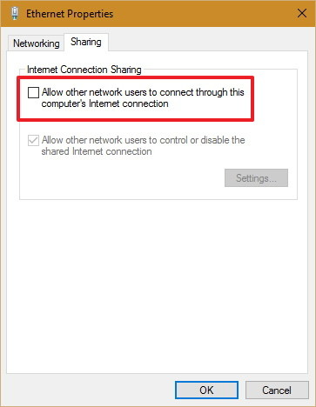](http://www.windowscentral.com/sites/wpcentral.com/files/styles/xlarge/public/field/image/2016/02/stop-internet-connection-sharing.jpg?itok=OJGhk5E3)

1. Click **OK** to complete the process.